Chapter 6: Indices and surds

Test A answers

Part A – Multiple-choice
1 C
2 B
3 E
4 D
5 B
6 E
7 C
8 A
9 E
10 D

Part B – Short-answer
1 a i 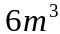 ii 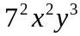 b 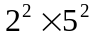
2 a 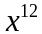 b 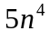 c 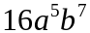 d 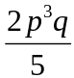
3 a 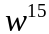 b 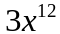 c 1 d −9
4 a 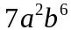 b 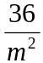 c 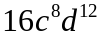 d 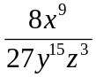
5 a 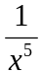 b c 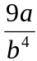 d 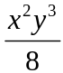
6 a 11 b 4
7 a 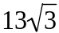 b 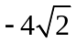 c 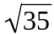 d 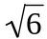

Part C – Extended-response
1 a 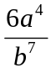 b 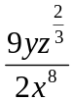
2 a i 0.000000065 mm ii 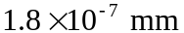 iii 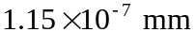
2 b i 21 960 000 000 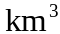 ii 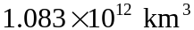 iii 